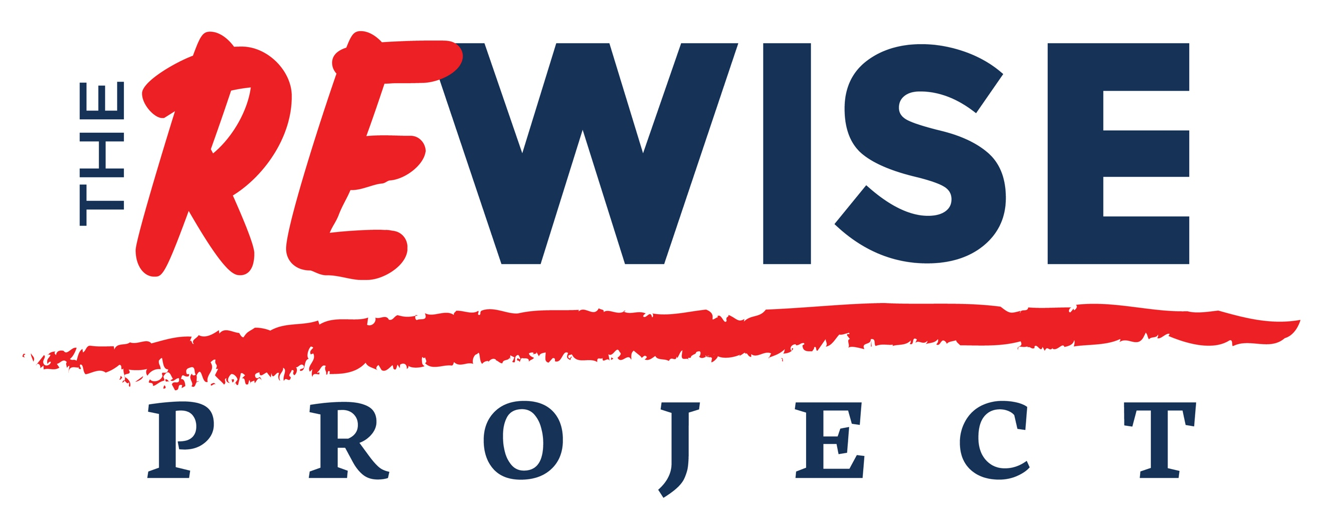

“Setting Up a Private Practice” Workshop
Saturday, 11th August 2018

REGISTRATION FORM

*Mandatory (Please, PRINT your details)

Full Name*
Address*
Email*
Phone*
Profession*

Are you a qualified counsellor YES / NO

Terms and Conditions

To register for the workshop please send the completed form to info@rewiseproject.co.uk and pay the deposit or the full amount to The ReWise Project CIC.

Your place will be confirmed once the payment is received.

Early Bird. Early Bird fee has to be paid in full by 30th June 2018.

Paying the DEPOSIT. If you pay the deposit only, please ensure full payment is paid by 1st August 2018 . Once we receive the full payment we will email you confirmation, full address of the venue and other details.
Note that the deposit is non-refundable.

Full Fee.
Full fee will apply for any payments done after 1st July 2018. The registration closing date is 1st August 2018.

Please tick the relevant box:
Early Bird fee (before 30th June 2018) | Deposit | Full fee (after 1st July 2018)
£75 | £40 | £90

Bank details for online transfer:

Name | The ReWise Project CIC
Account Number | 03483215
Sort Code | 20-18-93
Reference | For reference please use PP plus your initials.  For example: to register John Smith would use – PPJS.

I agree to the terms and conditions:

Signature |  | Date

